Student Development Index
Software Requirements Specification
(SRS) Document

Kasymbekova Bagira
Omurgazieva Nasik
Gairatbekov Kasymbek

Contents

1. Introduction 3
2. General Description 3
3. Functional Requirements 4
4. Interface Requirements 4
4.1 User Interfaces 4
4.2 Hardware Interfaces 4
4.3 Communications Interfaces 4
4.4 Software Interfaces 4
5. Performance Requirements 4
6. Other non-functional attributes 5
6.1 Security 5
6.2 Usability 5
6.3 Reliability 5
6.4 Maintainability 5
6.5 Portability 5
6.6 Performance Monitoring 5
7. Operational Scenarios 5
8. Preliminary Use Case Models and Sequence Diagrams 6

1. Introduction
  - Introduction
The purpose of this document is to define and describe the requirements of the Student Development Index (SDI) platform and to outline the system’s core functionality and constraints.

  - Scope of this document
The primary users of the system are students, designated verifiers, and university administrators, while the development team is responsible for building and maintaining the platform. The constraints for this project include the timelines and requirements set by the institution overseeing the SDI implementation.

  - Overview
The product is a web-based platform that allows students to register with their student ID, create a profile, and upload evidence of extracurricular achievements. Designated verifiers review submissions, award coins based on predefined criteria, and the system compiles these results into a student ranking.

2. General Description
2.1 Product Functions
The product should allow students to easily submit their extracurricular achievements and enable verifiers to review and approve submissions in a streamlined and efficient manner. It should also automatically calculate coin-based scores and generate student rankings.

2.2 User Characteristics
The users include students who upload evidence of their achievements, verifiers responsible for validating submissions, and administrators who oversee system operations. Basic digital literacy is required, and users should be comfortable navigating web interfaces and uploading documents or images.

2.3 User Problem Statement
Students participate in various extracurricular activities, but there is no central system to track, verify, and reward these efforts. As a result, achievements often go unnoticed, and student engagement is hard to measure.

2.4 User Objectives
Users want a platform that simplifies the submission, verification, and storage of extracurricular accomplishments. The system must support quick data entry, transparent verification, and accurate ranking generation based on predefined criteria.

2.5 General Constraints
The system must have an intuitive and user-friendly web interface accessible from both desktop and mobile devices. It must ensure secure storage and handling of student data and support real-time verification and ranking calculations. Additionally, the platform should be maintainable and scalable to accommodate increasing numbers of students and submissions over time.

3. Functional Requirements
- Student Registration: The system shall allow students to register using their student ID and create a personal profile.
- Submission of Achievements: Students shall be able to upload evidence of extracurricular activities, including volunteering, club participation, projects, and competitions.
- Verification Process: Designated verifiers shall be able to review submissions, approve or reject them, and assign coins based on predefined criteria.
- Coin-Based Scoring: The system shall calculate scores and rankings automatically based on the total coins awarded to each student.
- Reporting and Analytics: Administrators and verifiers shall be able to generate reports on student participation, rankings, and overall engagement statistics.
- User-Friendly Interface: The platform shall provide intuitive web forms and dashboards for students, verifiers, and administrators.
- Data Security and Privacy: The system shall securely store all user data and submissions, ensuring compliance with institutional privacy requirements.
- Notifications: The system shall notify students of verification results and any updates related to their submissions.

4. Interface Requirements

4.1 User Interfaces
The SDI platform will provide a clean, modern web interface designed for students, verifiers, and administrators. Each user group will have tailored dashboards that simplify tasks such as submitting achievements, reviewing requests, or viewing analytics. The interface will prioritize clarity, ease of navigation, and accessibility across devices.

4.2 Hardware Interfaces
The SDI platform does not require any specialized hardware and users can access it from standard devices such as laptops, desktops, tablets, or smartphones. The server handles all processing and storage, while user devices only need a modern web browser.

4.3 Communications Interfaces
- The system uses standard web protocols (HTTP/HTTPS) to communicate between client devices and the server. The system transmits notifications, data submissions, and verification updates securely, ensuring real-time interaction between students, verifiers, and administrators.

4.4 Software Interfaces
The system will operate as an independent web platform that communicates with its backend services through standard web protocols. Users will not need additional software, as all interactions occur within the web interface.

5. Performance Requirements
- System Responsiveness: The platform shall load pages, forms, and dashboards within 3 seconds under normal usage conditions.
- Concurrent Users: The system shall support at least 500 simultaneous users, including students, verifiers, and administrators, without performance degradation.
- Data Uploads: File uploads (images, documents, certificates) shall be processed within 10 seconds for files up to 10 MB.
- Ranking Updates: Student rankings will automatically update within 1 minute after verifiers assign coins.
- Availability: The system shall be accessible at least 99% of the time, excluding scheduled maintenance periods.
- Scalability: The platform shall be capable of handling growth in student users and submissions without major redesign, including support for additional universities if expanded.
- Backup and Recovery: The system performs daily backups and can recover from failures within 2 hours to minimize disruption.

6. Other non-functional attributes

6.1 Security
All user data, including personal information and uploaded documents, shall be securely stored and encrypted. Access control shall ensure that only authorized verifiers and administrators can approve submissions or view sensitive data.

6.2 Usability
The platform shall provide an intuitive and user-friendly interface with clear navigation for students, verifiers, and administrators. Inline guidance, help sections, and onboarding guidance will be available to assist new users.

6.3 Reliability
The system shall operate consistently without unexpected crashes. Daily automated backups shall ensure data integrity and support recovery in case of failure.

6.4 Maintainability
The system will be modular and include clear documentation to allow easy updates, bug fixes, and addition of new features by the development team.

6.5 Portability
The platform shall be accessible via modern web browsers on desktop and mobile devices. Minimal dependency on specific operating systems ensures wide accessibility.

6.6 Performance Monitoring
Administrators shall have access to logs and system performance metrics to monitor usage, detect errors, and optimize performance.

7. Operational Scenarios
Scenario A: Student Registration and Profile Creation.
A new student logs into the SDI platform using their student ID. They complete their profile by entering personal information, educational details, and areas of interest. Once submitted, the system stores the data securely and confirms successful registration.
Scenario B: Submitting Extracurricular Achievements.
A student uploads evidence of volunteering, club participation, or project involvement. The submission form allows attaching documents, images, or links. The system validates the input, saves the submission, and notifies the assigned verifier.
Scenario C: Verification and Coin Assignment.
A verifier reviews a student’s submission. They assess the activity based on predefined criteria, approve or reject it, and assign coins accordingly. The system updates the student’s profile and ranking in real-time.
Scenario D: Ranking and Reporting.
Administrators generate reports to view overall student engagement, top-performing students, and participation trends. The system aggregates coin totals, produces rankings, and exports data to CSV or Excel if needed.
Scenario E: Notifications and Alerts.
Students receive notifications after the system verifies their submissions, assigns coins, or updates occur. Verifiers receive alerts when new submissions require review.

8. Preliminary Use Case Models and Sequence Diagrams
This section presents a list of the fundamental sequence diagrams and use cases that satisfy the system’s requirements. The purpose is to provide an alternative, "structural" view of the requirements stated above and how they might be satisfied in the system.
  - UML Diagram
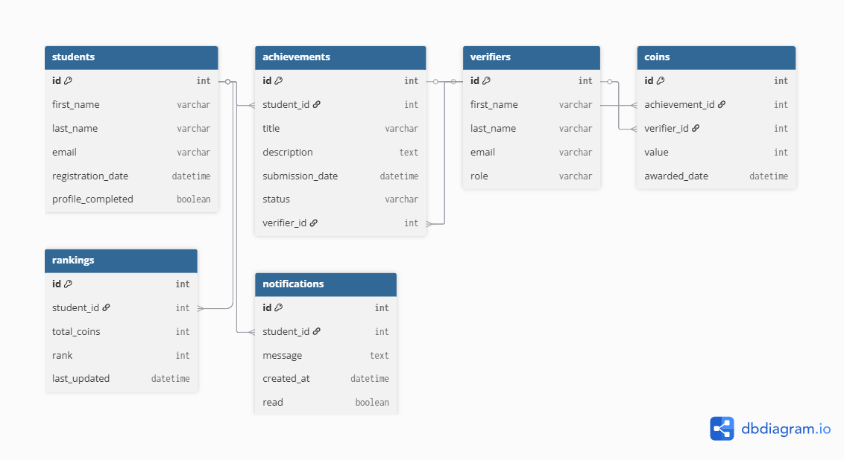

  - User case Diagram

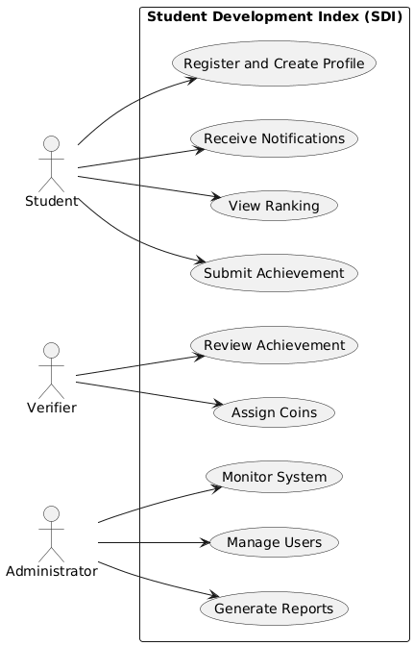

8.3 Sequence Diagram

